The 21st Century Principal

The DoDEA 21st Century Principal creates, leads, and sustains a collaborative school culture that engages the collective wisdom of the school and community to:

* 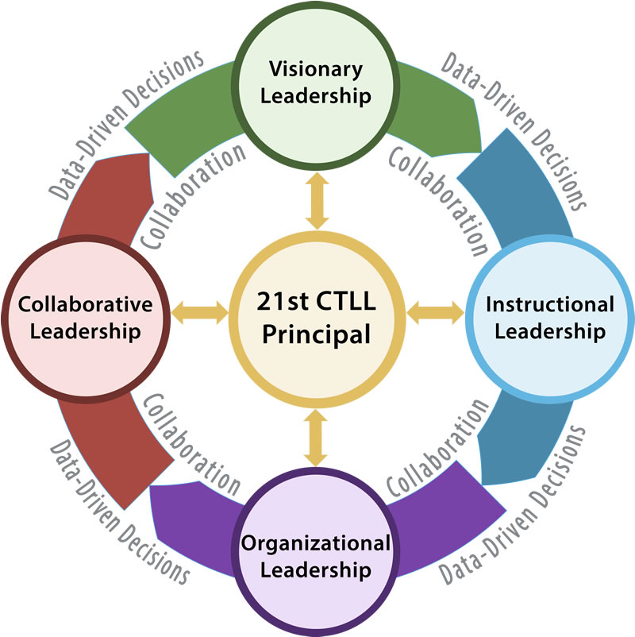Build a shared commitment to excellence and a vigorous pursuit of high student performance.
* Ensure a student-centered school environment that provides and nurtures innovative learning experiences for all students to prepare them for success in life.
* Lead the school’s collective entrepreneurial spirit to remove barriers, challenge the educational system’s status quo, and empower students to utilize their curiosity, discovery and creative problem solving skills.
* Empower all staff, parents, and students to collaboratively and deliberately use data to support every student's academic, social, and emotional growth.
* Activate and sustain community partnerships and mentorships that maximize all resources available for the success of military children.

# Leadership Roles

## Visionary Leadership

The visionary leader builds a shared commitment to excellence and a vigorous pursuit of high student performance.

## Instructional Leadership

The instructional leader ensures a student-centered school environment that provides and nurtures innovative learning experiences for all students to prepare them for success in life and empower all staff, parents, and students to collaboratively and deliberately use data to support every student's academic, social, and emotional growth.

## Organizational Leadership

The organizational leader creates, leads, and sustains an entrepreneurial culture that engages the school and community to remove barriers and maximizes resources for student success.

## Collaborative Leadership

The collaborative leader activates, communicates, and sustains the engagement of staff, parents, students, military and community partnerships and shared leadership for the success of military children.