# 21st Century Professional Learning Framework

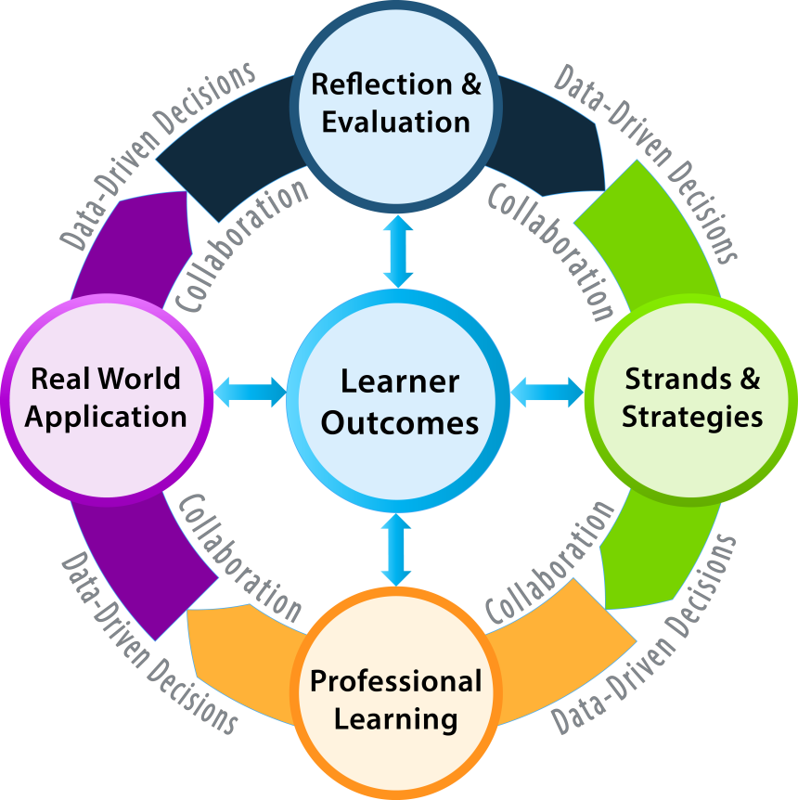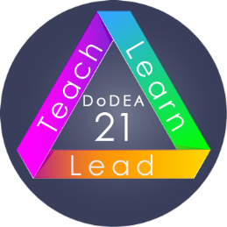DoDEA introduces professional development opportunities for educators serving in DoDEA offices and schools. The Professional Learning Framework (PLF) provides a continuous, customized professional learning cycle that evolves to support and meet the needs of our educators over the next several years. The cycle is universal and applies to all learners and to all types of content.

## Learner Outcomes

## The cycle begins in the center and focuses on the outcomes for the learner. The learner outcomes connect to the 21st century skills that are to be learned and demonstrated. 21st century skills and the content standards work together. The 21st century skills are taught through the standards. Whether educators use the DoDEA Standards or the Common Core State Standards, content and skills together create the 21st century learner outcomes.

## Reflection and Evaluation

## Once the learner outcomes and the 21st century skills are established, the learner(s) reflect on what they know by using the Reflection and Evaluation Rubrics (teachers and students) or the Self-Assessment and Reflection Continuum (administrators).

## Strand and Strategies

After self-evaluation, the learner(s) moves to the toolbox of different strands of learning opportunities to determine and to choose the strategy(ies) that best support the learner needs for the established outcomes.

## Professional Learning

The engagement in learning occurs during the professional learning or collaborative timeframe. The learner or a group of learners delve into the choice of their learning. The learner or group work together using the professional learning guide that promotes inquiry, application, and data results of the learning.

## Real-World Application

Following the collaboration of learning, the learner(s) apply the learning appropriately. Leaders apply the learning to the context of the school and/or the community. Teachers apply the learning to teaching and learning in the classroom and/or an aspect of the school. Students apply their classroom knowledge to their personal lives, school, community, and/or global aspects learning. Evidence of learning is gathered to determine how successful the application of the learning has been.

**Conclusion**

The cycle concludes with a reflection on the learning and its evidence of success. A new learning cycle grows from the data to place the learner(s) on a continuous learning path. The continuous learning cycle’s intent is to deepen knowledge and broaden its application to multiple aspects of life and work for all learners.