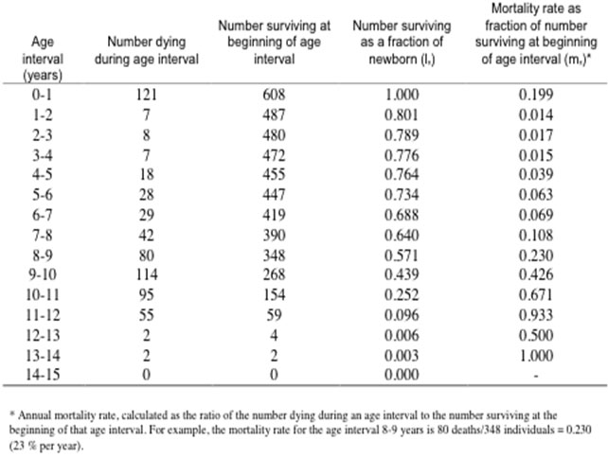

1. What do you know about the way this study was conducted based on what you observe in the table above?
2. What don’t you know about this study from observations of the table?
3. What trends or patterns are evident in the data? What are the most obvious or important conclusions that can be drawn from these data?

a.

b.

1. Construct a survivorship curve of the sheep data by plotting age class midpoint (0.5 – 14.5 years on *x*-axis) versus number surviving at the beginning of the age interval (*y*-axis). Copy and Paste or Insert your diagram below. (10 points)
2. Suggest hypotheses that might explain the shape and trend of this curve.

Human population life tables

1. a. Using Excel, construct life tables (should be in the form of the sheep life table) for the total populations surveyed (historical and modern) from Groton, Mass. Copy and Paste or Insert your tables below. (10 points)
2. Create one graph that has shows both male and female populations from pre-1820s and post1900 data sets. (10 points)
3. a. Which age intervals in your life tables show the greatest mortality risk in each population (historical vs. modern)?

b. What statistic gives you this information?

1. What do the survivorship graphs tell you?
2. a. Are there gender differences in survivorship in either population?

b. What examples show you this?

1. How would the differences in survivorship between men and women affect the potential for population increase?

11. What explanations can be given to account for any differences or similarities in survivorship and mortality rates observed among the populations?

12. What may account for the differences between the sexes?

13. Do the data collected represent an accurate picture of mortality rates in human populations?

1. Why or why not?
2. What are some of the assumptions?
3. What are some of the limitations and biases of the data collected?

14. a. What are some things that you still do not know at the end of this lab (In other words, what are some new questions that have been generated by the study)?

b. How would you go about finding out the answers?